User Guide

FlyBy is very simple, userfriendly application to book flight tickets. If you want to use FlyBy you need to registrate and login. This application was created so that passengers will have an easy time to find a cheap flight from Košice to Bratislava and vice-verca.

REGISTRATION
- Enter your login
- Enter your password
- Enter password verification
- Enter your e-mail
- Enter your phone number
- Enter your first name
- Enter your last name
- Click to“Confirm“
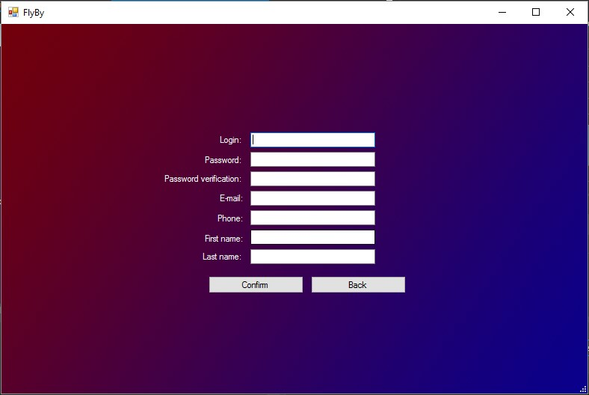

LOGIN
- Enter your user name
- Enter your password
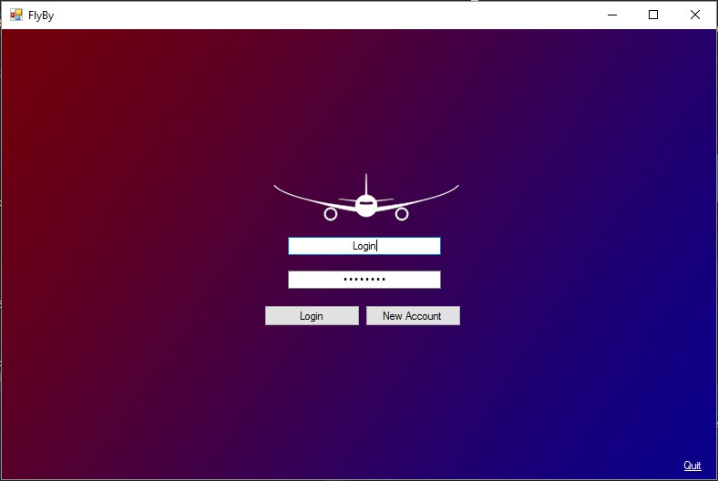
- Click to „Login“

ADMIN INTERFACE

